CHAPTER 1 INTRODUCTION
1.1 Introduction about Project
1.2 Present state of the art / existing system
1.3 Need of Computerization of System/ Problem in existing system
1.4 Proposed Software (What would S/W accomplish?)
1.5 Importance of the Work/project

1. INTRODUCTION
1.1Introduction about project
The aim of this project is to convey need the parking system. This system has been developed to overcome the problem of manual system. This system focuses on the reduction of error and be more precise and easy to use. Delhi is one of the most crowded city of our country car parking issues also leads to traffic jams are software names on the management of car parking on the basis of their type. Keeping their record and managing all the data related to the car parking.
The project thus calculates the parking ticket’s price, number of transactions. It performs the tasks which are related to automated parking system which includes inserting list of a new sots, parkingfare, viewing all the listed slots as well all of the transactions made and all jobs related to generation of a parking ticket.
The project aims at reducing the data duplication and reducing the manual work it saves time and resources and increase efficiency.
1.2 Present state of the art/existing system

The existing system performs most of the tasks manually. The individuals are assigned to perform the particular task which consumes more time and resources and hence, highly prone to human made errors. The large amount of data is difficult to handle and operate ,the data corruption and data manipulation is easier in manual system. The calculation and real time update is also not to the point hence, data integrity is lowered. The old manual system was suffering from a series of drwabacks.since whole system was to be maintained by hands the process of keeping, maintaining and retrieving the information was very lengthy.keeping systemic order of records becomes tough which leads to unnecessary consumption of time and efforts. Being manual it becomes less reliable and trustworthy the scope of error and mistakes reduces in case of automated parking management system.

1.3 Need of computerization of system/problem in existing system
Problem in existing system are:
- Lack of security of data.
- More man power.
- Time consuming.
- Needs manual calculations.
- it is not data friendly
- it is complicated to use
- no real time update
- do not modify user’s data
- no loading bar
- no password facility
- do not contain comments
- poor-identification

1.4 Proposed software (what would software accomplish?)
Proposed system is an automated parking management system through our software user can add slot, search slot, buy pariking ticket.
It may help collecting perfect management in details. In very short term. The collection will be obvious, simple and sensible. Equal also help in solving the current problem relating to the parking issues.

Our proposed system has the following advantages:
- User friendly interface
- Less errors
- Real time information update
- More storage capacity
- Searching facility
      - User friendly (i.e. simplifies the needs of user with several inputs)
      - Password Facilitated
      - Transaction records are stored
      - Comments simplifying every object and making it relevant
All the manual difficulties in managing the transaction and movie records have been rectified by implementing computerization.
1.5 Importance of the work / project
Project management is important because it ensures what is being delivered is right and will deliver real value against the business opportunity. Every client has goals which are to be achieved by the project strategically. The project plan contains tasks, activities, goals, dependencies and resources needed for the successful completion of the project.
Our project has improved the quality of the performance of task, now it is done in more efficient and effective manner. The data is more safe and precise and form the customer’s point of view reduced manpower requirement and more reliable data handling.

CHAPTER 2 SYSTEM ANALYSIS

2.1 Analysis Methodology /requirement gathering techniques
2.2 Feasibility Study
2.3 Choice of Platforms
2.3.1 Software used
2.3.2 Hardware used

SYSTEM ANALYSIS
2.1 Requirement gathering techniques
- One-on-one interviews
The most appropriate method for the collection of genuine information from the users (customers ,managers, administrators) is to have a healthy discussion. An open-end face-to-face talk would easily help the programmer to draw the conclusions and identify user’s requirements.
- Questionnaire
After observing the customer’s behavior a set of questions is prepared which is to be answered by the customer seeking their suggestions and feedbacks. It gives view statically.
- Observation
The users are observed keenly, their response and behavior regarding the situation is clearly noticed. They are observed in the real life situations and hence, the conclusions are drawn about their requirements. The aim is to understand the customer’s psyche.

2.2 Feasibility study
The feasibility is conducted to perform the SWOT analysis on a system i.e. identifying its strengths and weaknesses, how it is different from other systems what are its advantages and disadvantages. Opportunities and threats, how it can be improved or what changes are expected in future.

2.2.1 Operational feasibility study
The operational feasibility focuses on the working of the system. Whether the system is able to solve the problems, what are its strengths and weaknesses . what is the scope for improvement and how many phases it contain.
Our system has almost stood on the customer’s expectations but still there are scope for improvement as deletion of parking ticket is not available.

2.2.2 Technical feasibility study
The technical feasibility is based in the outline of design on which the software is prepared. What level of expertise is required to operate the system, is it customer friendly or not the level of complexity it contains etc.
Our system is user friendly and understandable it is easy to operate being a interactive system which make it more easy to use.
2.2.3 Economical feasibility study
The economical feasibility is judged upon the monetary factors the cost of the system is valid or not, is it affordable or not, does its cost justifies its use etc
Our system haven’t used the costly resources the methods and techniques used to developed it are not so costly hence its production cost is not high which makes it affordable.

2.3 Choice of Platforms
2.3.1 Hardware used
Processor Intel® Pentium® CPU N3700 @ 1.60GHz (4 CPUs), ~1.6GHz
Clock speed 1000 MHZ
Framework bus 64 bits
RAM 8 GB
HDD 1 TB
Keyboard 108 Keys
Mouse 2 buttons Logitech mouse
2.3.2 Software used
OS MS WINDOWS 10
Front end TURBO C
Back end file handling

CHAPTER 3 SYSTEM DESIGN

3.1 Process Model used
3.2 Database Design (ERD/Data Dictionary/ Table Design)
3.3 Functional Design (DFD)
3.4 Interface Design (Screen shots of forms)
3.5 Output Design (Screen Shots of Report)

3. SYSTEM DESIGN
3.1 Process model used
3.1.1 Waterfall model
The waterfall model is a chronological design process, in this model; progress is seen as sloping certainly downwards through the stages of requirement gathering and analysis, system design, implementation, testing, development of system and maintenance. Mostly it is used in software development processes.
Waterfall
- Analyze the requirement
- Specify requirement
- Design the system
- Build the system
- Test system

Uses of this model
- The waterfall model is user friendly.
- It is easy to maintain each stage or phase has output and a review process which makes it rigid.
- In this model Phases do not intersect, they are processed and completed one at a time
- It works well for minor projects where requirements are very well understood.

Why use this model
Our system is focusing on few requirements in which phases and relation between them is well defined. The requirements are clearly stated and are easy to understand.

Waterfall diagram

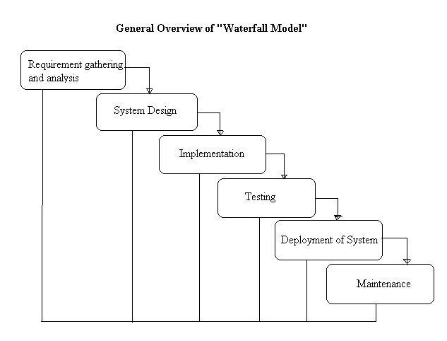

3.2. Functional Design (DFD)

A data flow diagram (DFD) is a graphical representation of the "flow" of data through an information system, modeling its process aspects. A DFD is often used as a preliminary step to create an overview of the system, which can later be elaborated

level 0/context DFD

A system context diagram (SCD) in engineering is a diagram that defines the boundary between the system, or part of a system, and its environment, showing the entities that interact with it. This diagram is a high level view of a system. It is similar to a block diagram

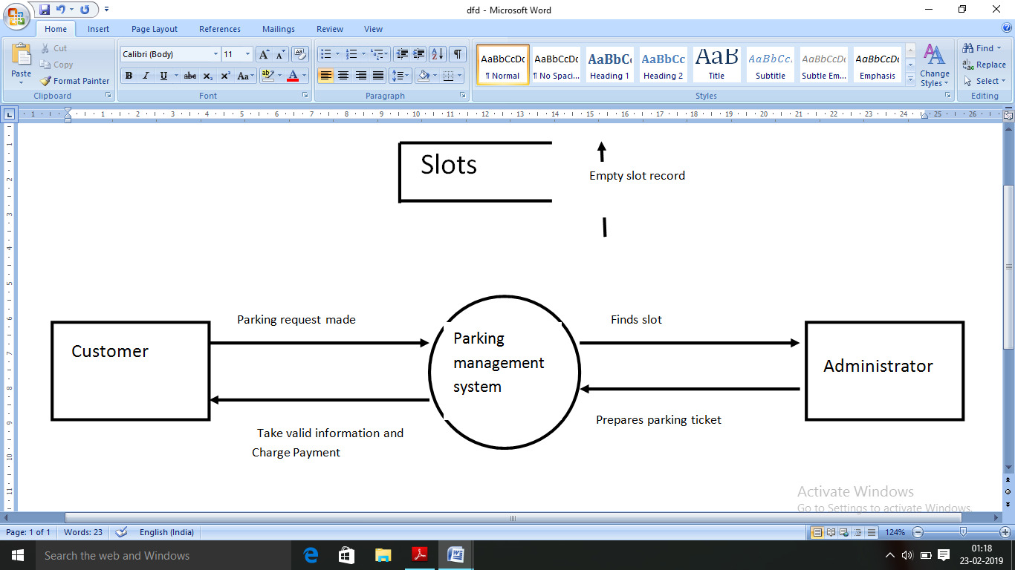

Level 1 DFD

As described previously, context diagrams (level 0 DFDs) are diagrams where the whole system is represented as a single process. A level 1 DFD notates each of the main sub-processes that together form the complete system. We can think of a level 1 DFD as an “exploded view” of the context diagram.

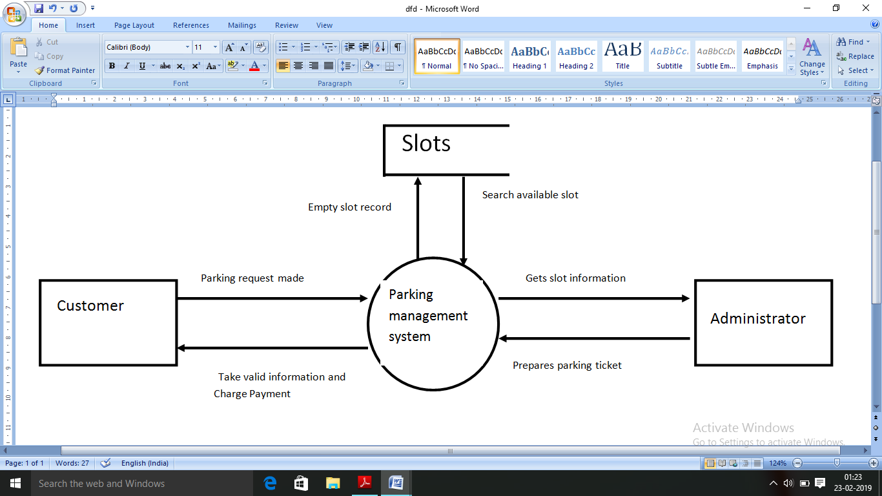

3.3 Interface design (screen shots of forms)
1. Declaration Section
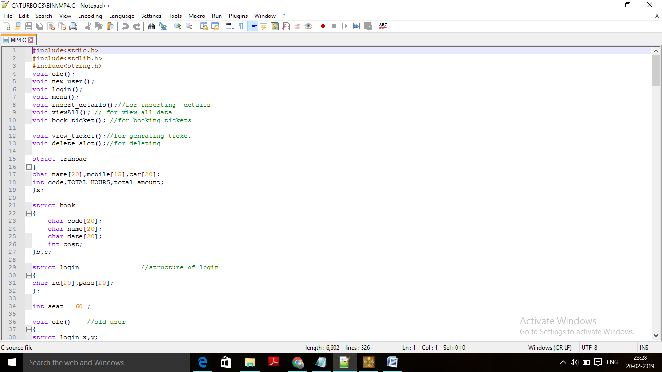
2. login
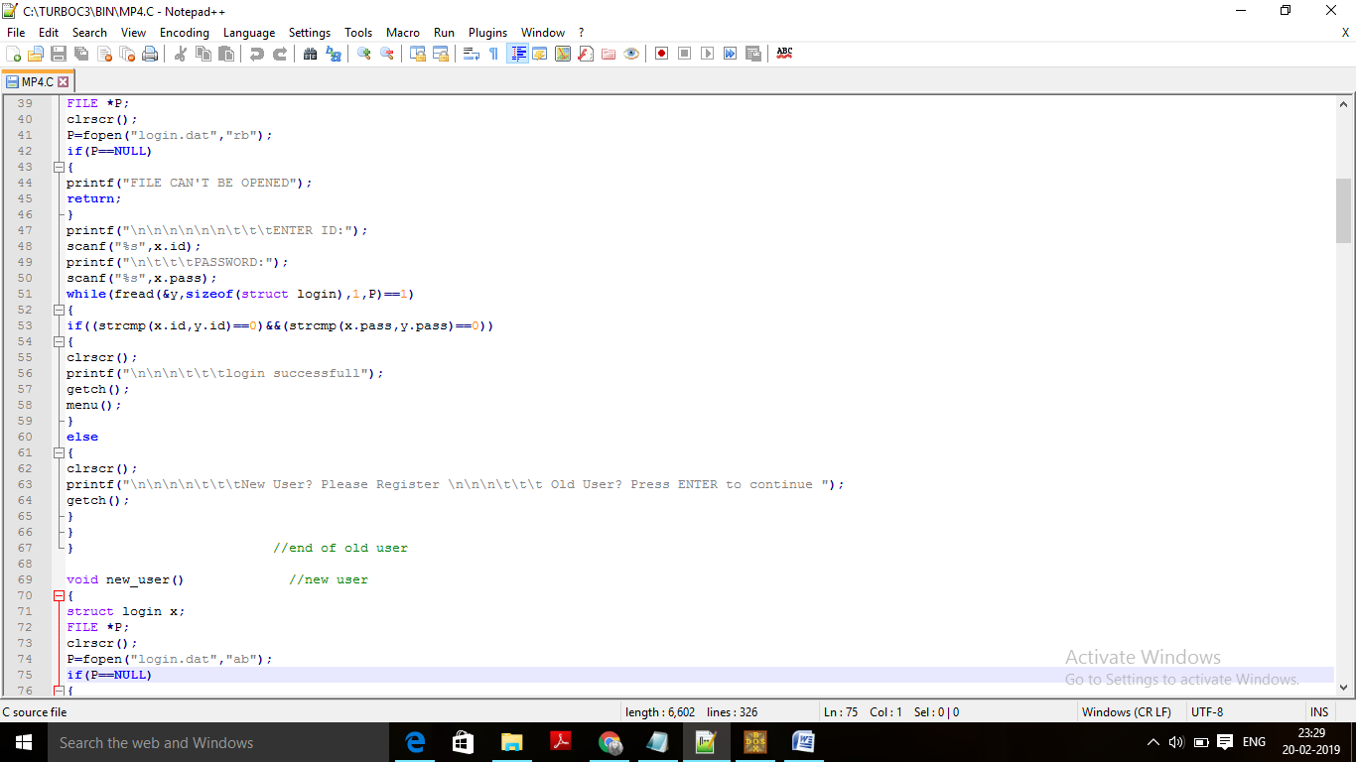

3.menu structure
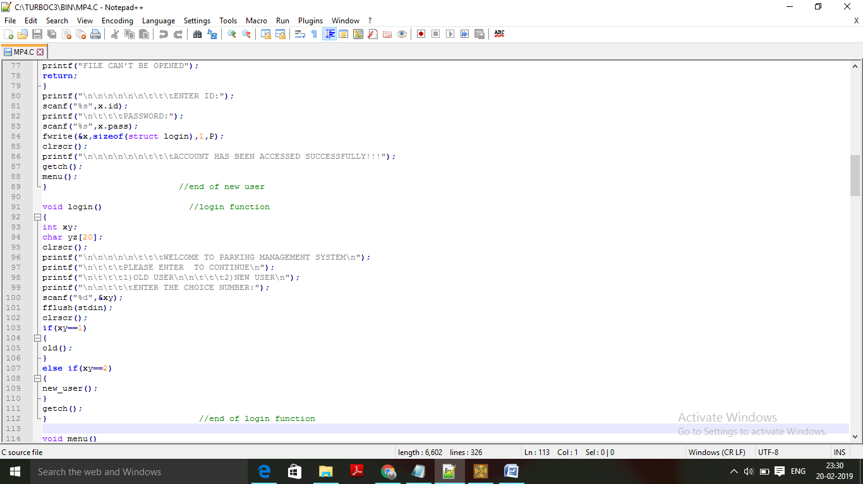
4. main menu
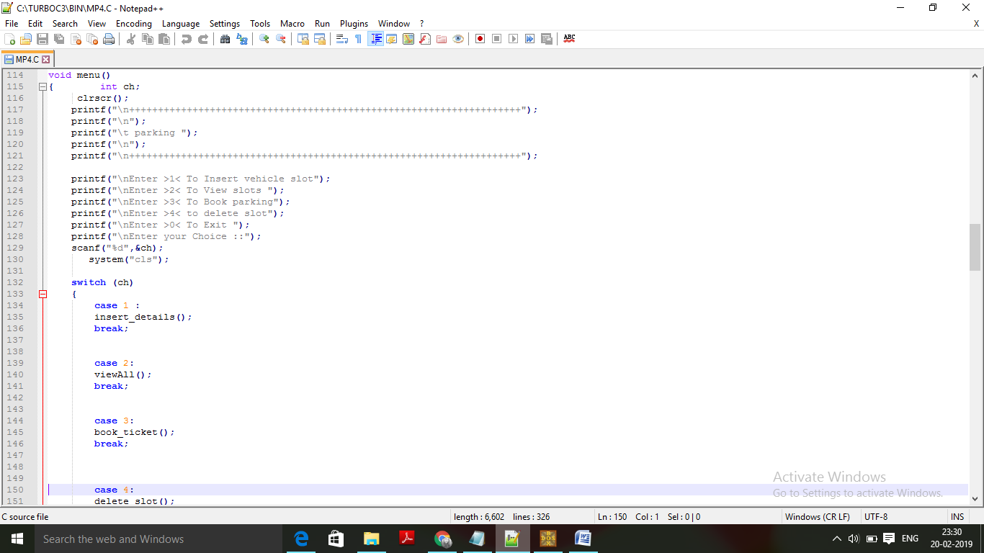

5. void insert_details
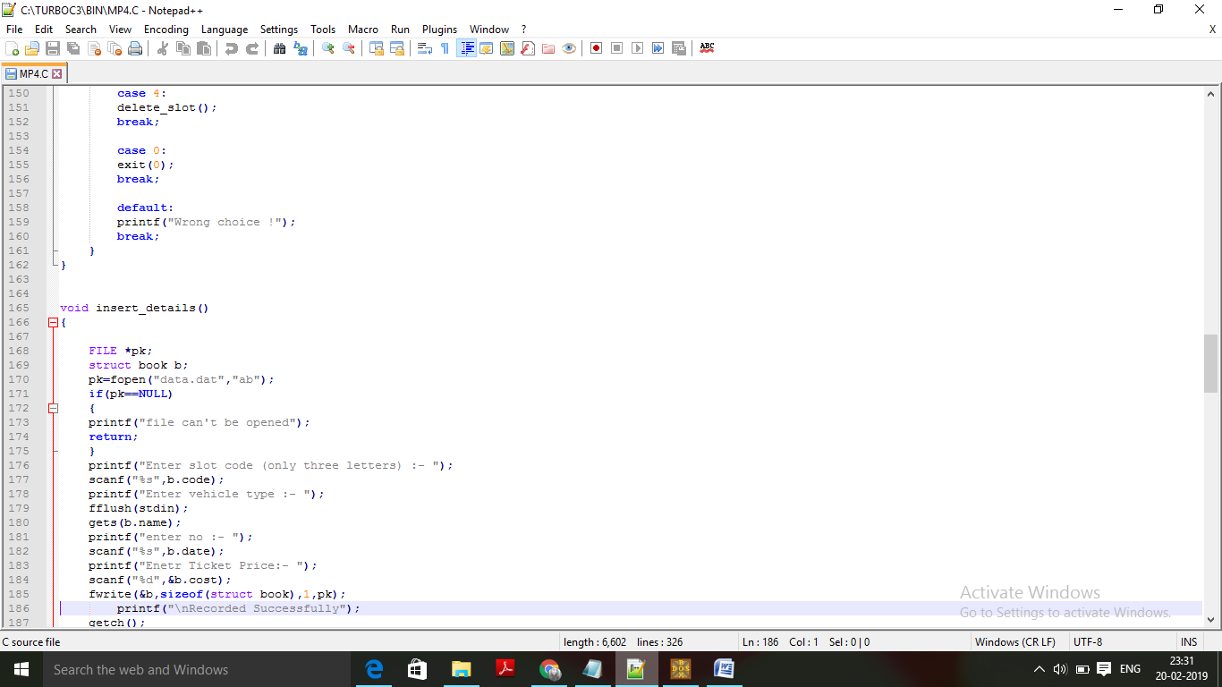
- Void view_all
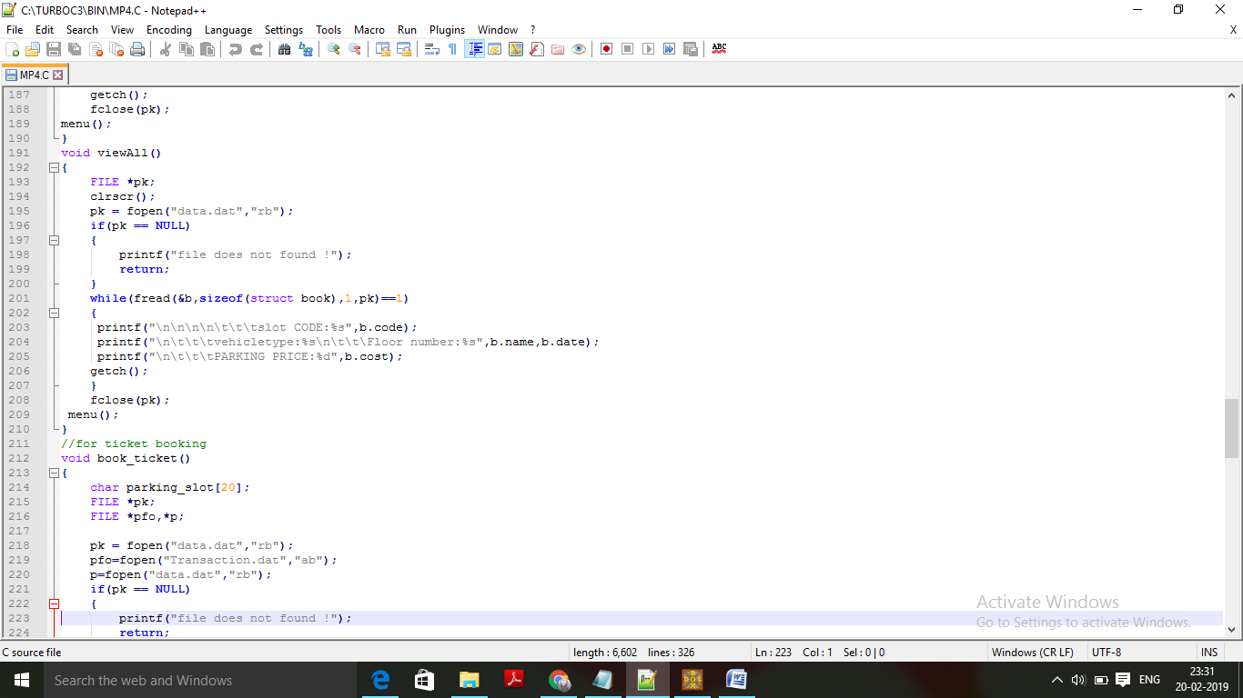

7. void book_tickets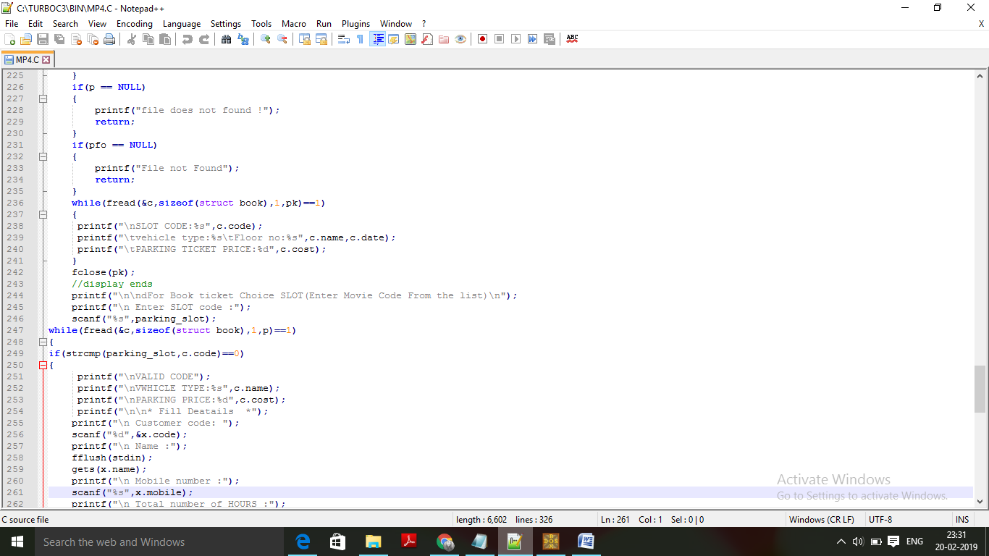
8. void delete_slot
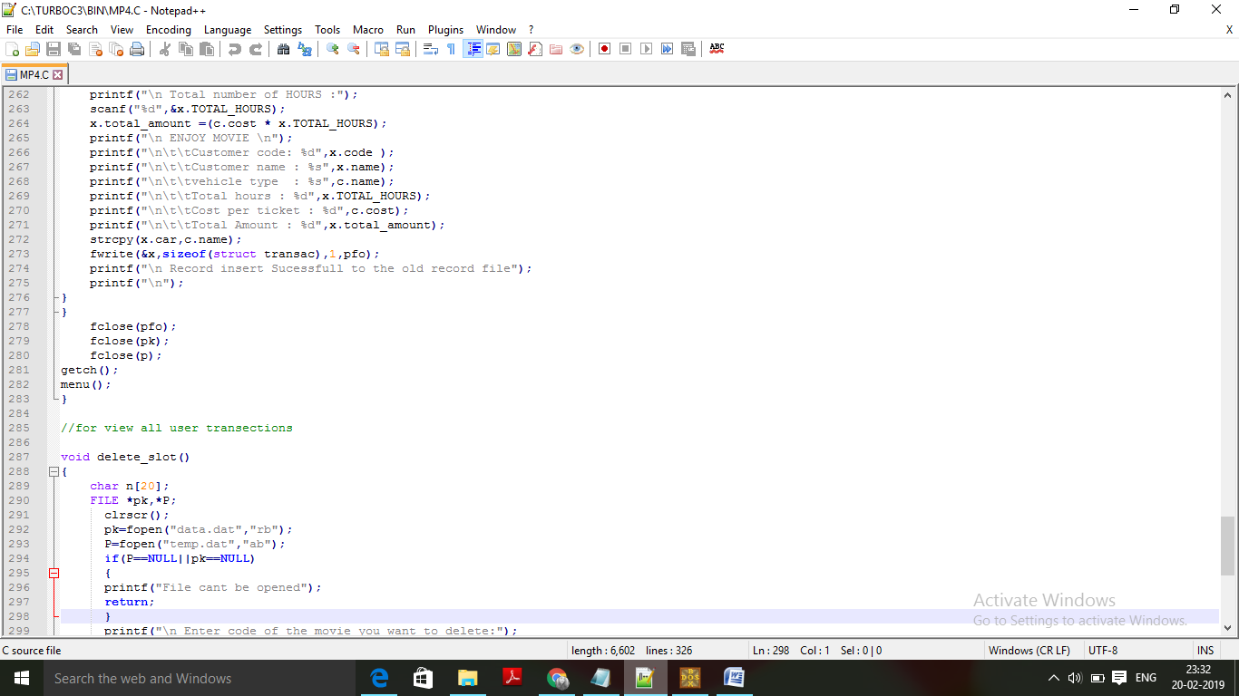

9.end
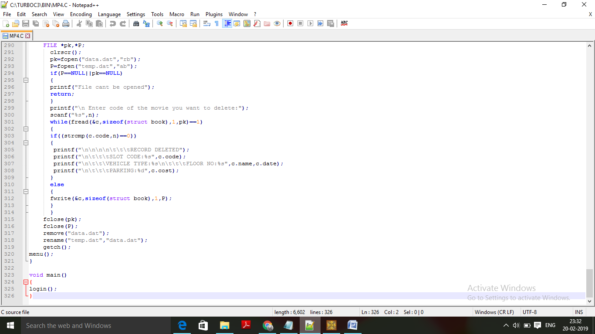
3.4 Output Design (Screen Shots of Report )
1. welcome screen
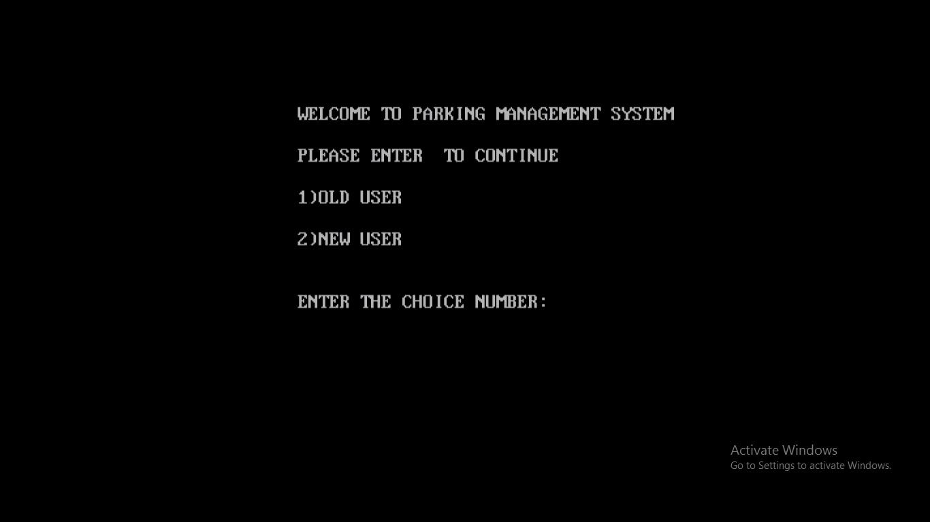

2. login screen
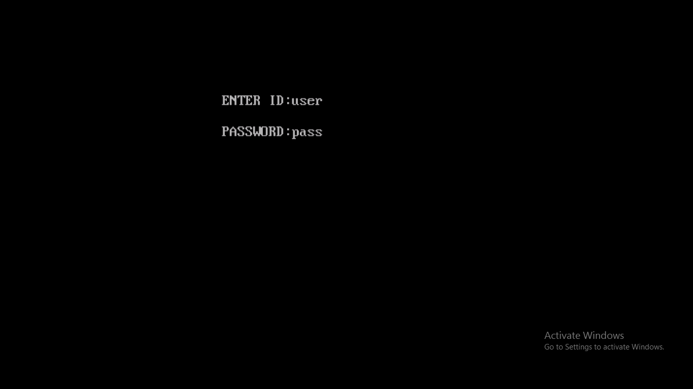
3. main menu

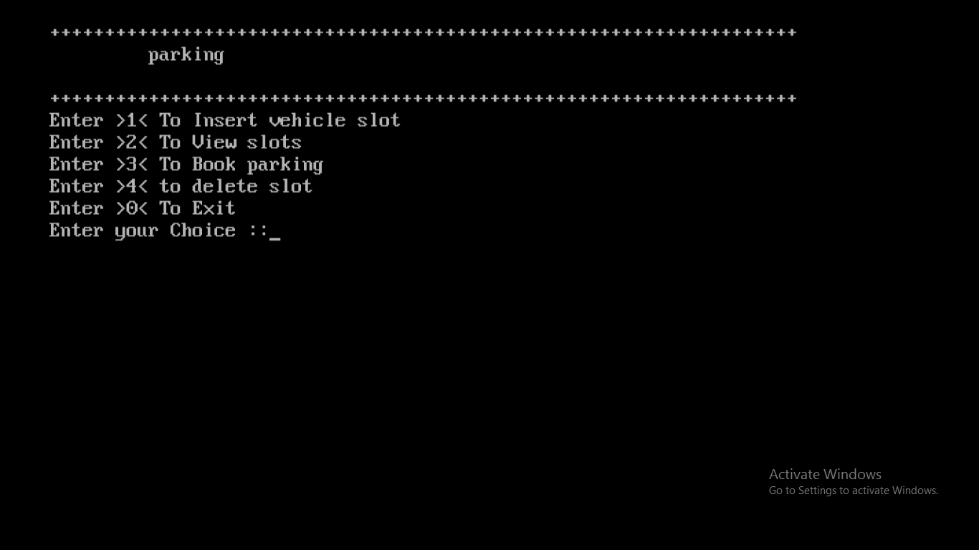

4. insert slot detail
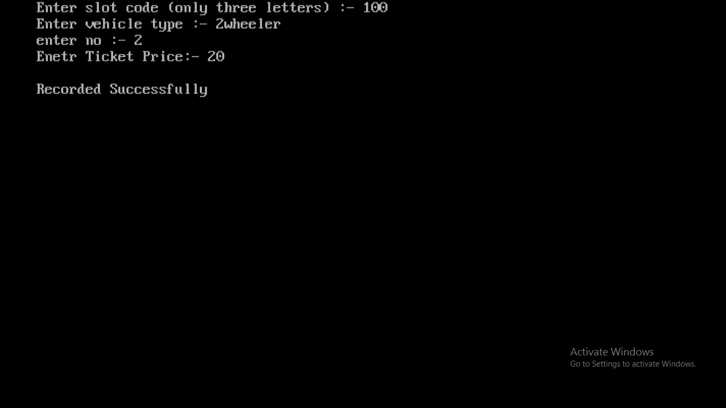
5. parking ticket
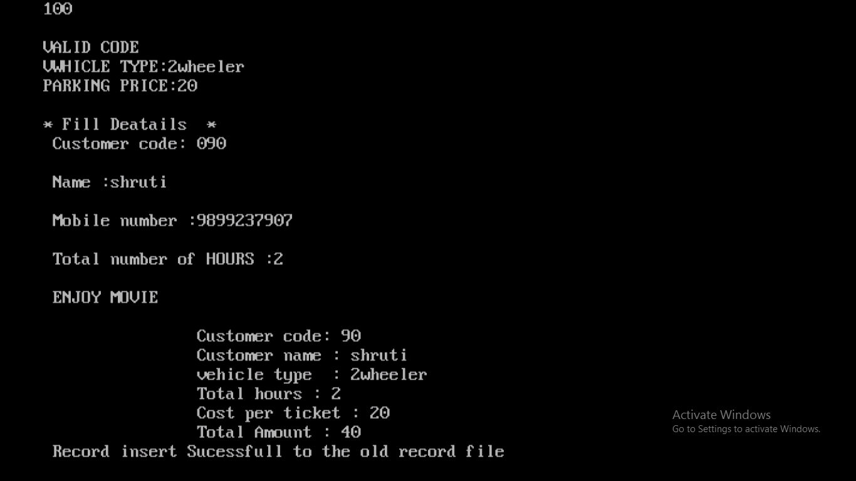

- Delete slot

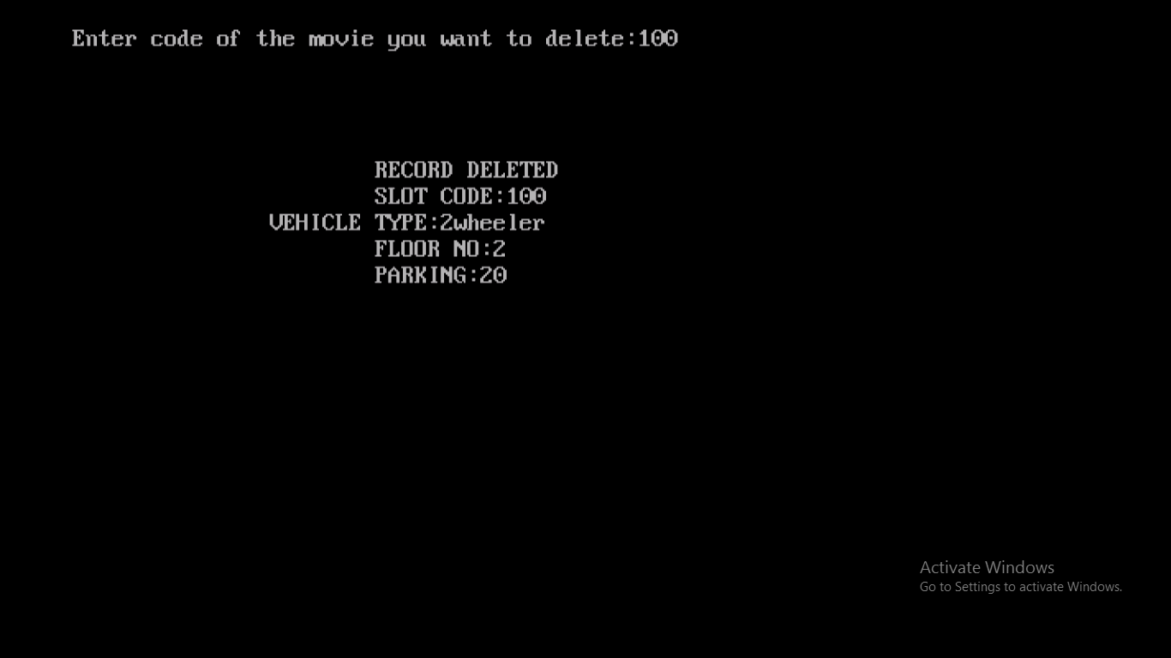
- View all available slots
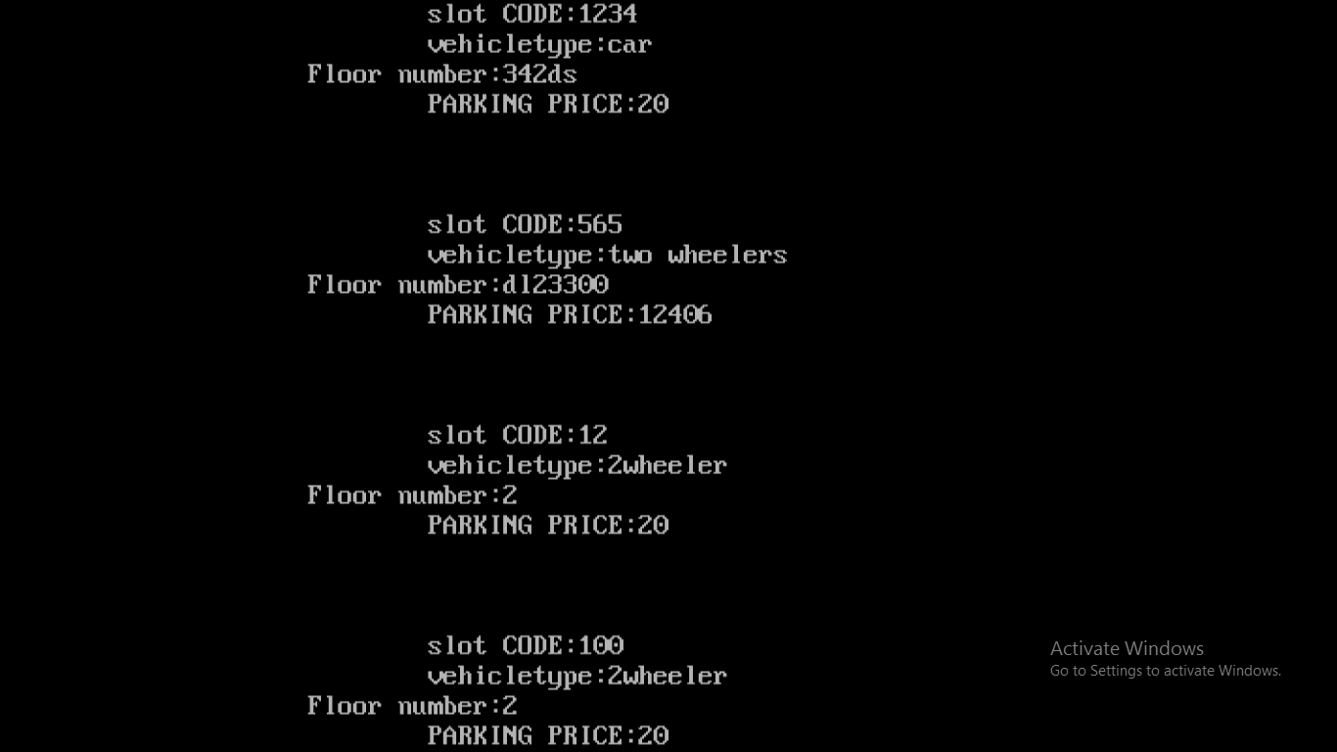

CHAPTER 4 TESTING AND IMPLEMENTATION

  - Testing Methodology (Types)
  - Testing Methodology applied(Why)
  - Test Cases
  - Test Data
  - Gap Analysis (Planned Vs Achieved)
  - Rework/ Retest
  - Implementation (Techniques)
  - Post implementation
  - Hardware & Software Requirement
    - Hardware Requirement
    - Software Requirement

4. TESTING AND IMPLEMENTATION
4.1 Testing Methodology
1) Unit Test - It is the most basic testing system. It only emphasizes over very little functions of the program. Hence, only covers the interaction of the code with memory. These dependencies are hard coded into the cook while testing.
Therefore it is equally important to test when all these units combined together are work in a cohesive manner which leads us to further type of testing.
2) Integration testing - It provides a mechanism to test the interoperation of smaller unity. It involves the testing of modules which are accessible to the network, database and the systems.
It reveals about the issue with network modules or database and most importantly in the connection between small units of code
4.2 Testing methodology applied
1) Unit Test - Unit testing covers only memory not a database and it also checks even the smallest unit of the code and checks whether there is any error in code.
2) Test Case – set of conditions where the tester verifies if a system verifies the requirements or not.
4.3 Test cases
Test case 1: result on entering slot detail
Test case 2: result on entering incorrect slot code while charging a ticket
Test case 3: charge ticket for multiple hours.
Test case 4: delete a slot record

4.4 Test data
The data that is used in test of a software system in order to test a software application is test data.

Table : 4.1

TEST DATA | INPUT | OUTPUT | INTERPRETATION | SCREENSHOT  NUMBER
TEST DATA 1 | SLOT NO: 100  VEHICLE TYPE: 2 WHEELER  FLOOR NO: 2  TICKET PRICE:20 | Record Inserted | This Module Is Working Properly | 1
TEST DATA 2 | ENTER WRONG CODE WHILE BOOKING | Exit from module | The ticket was not booked | 2
TEST DATA 3 | CHARGE FOR  MULTIPLE  HOURS | The Ticket Booking Details Are Shown | The Ticket Were charged Properly  Hence No Problem In charging fo Multiple hours | 3
TEST DATA 4 | DELETE SLOT CODE :100 | Slot Deleted | The slot Record Was Deleted | 4

- TEST DATA 1
- TEST DATA 2
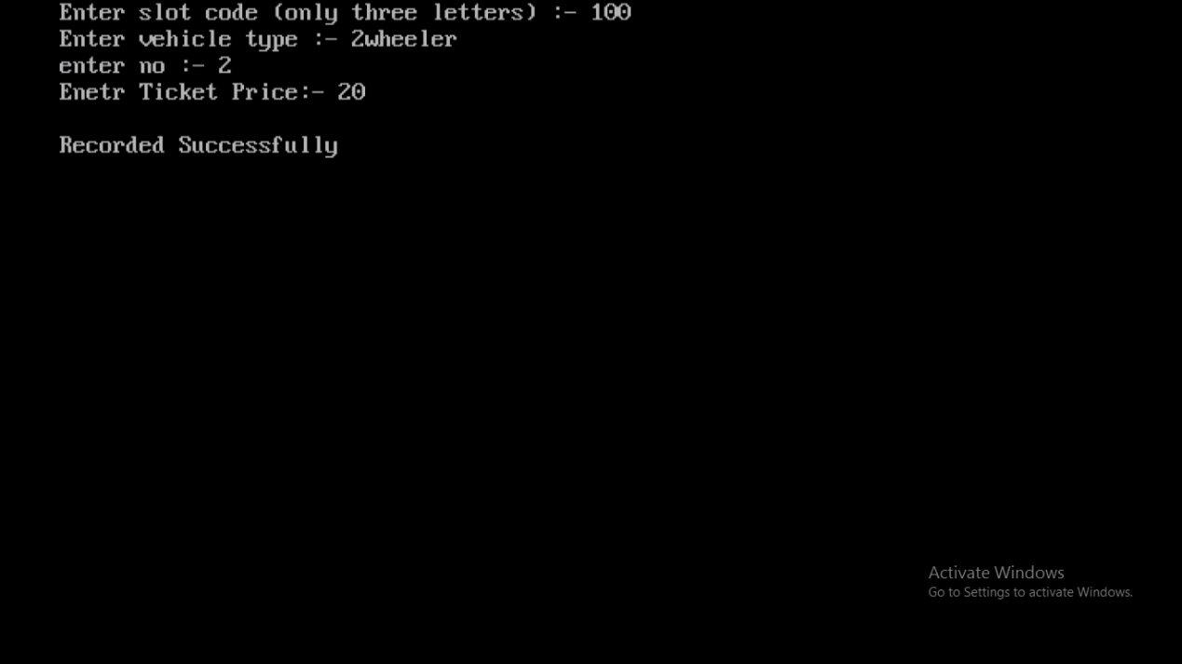
z

3.TEST DATA 3

- TEST DATA 4

4.5 Gap analysis
It compares the result which was planned to be achieved and which is actually achieved. Our system was planned to be more user friendly and less error prone. It was developed with an aim Of charging parking tickets easily. The deviation is calculated and thus corrected.
4.6 Rework
If there is any error, it is important to rectify it. Also, it should be rechecked and retested on different parameters after a specific period of time.
Checking and making compatibility is also necessary.
4.7 Implementation
After testing of the system, proposed system is installed at the [mall xy]. The term implementation may be defined as a process of converting the manual system with a newly developed system and making it functional without disturbing the functionality of the organization.
There are 3 types of implementation
1) Fresh Implementation
2) Replacement Implementation
3) Modified Implementation
4.8 Post implementation
A post implementation review is an evaluation of a system in terms of the extent to which the system accomplishes stated objective system accomplishes stated objective and actual project cost exceeds initial estimates.
It is normally carried out the people who have an independent view pt. and are not responsible for the development and maintenance of the system while evaluating a system, the following points are normally considered.
1) Performance Evaluation
2) Cost Analysis
3) Time Analysis
4) User Satisfaction
5) Documentation Review Plan
6) Hardware Review Plan
7) Ease for modification
8) Failure Rate
4.9 Hardware software requirements
4.9.1 Hardware Requirements:
Processor Intel®Pentium®CPUN3700@1.60GHz(4CPUs), ~1.6GHz
Clock speed 1000 MHZ
Framework bus 64 bits
RAM 8 GB
HDD 1 TB
Keyboard 108 Keys
Mouse 2 buttons Logitech mouse
4.9.2 Software Requirements:
OS WINDOWS 10
Front end TURBO C
Back end file handling

CHAPTER 5 CONCLUSION AND REFERENCES
5.1 Conclusion
5.2 Limitation of System
5.3 Future Scope for Modification
5.4 References/ Bibliography

5. CONCLUSION
5.1Conclusion
The main aim of our project was to provide customer a user friendly interface. It not only reduces the work load but also performs it in a more efficient and effective manner. In the system which we have prepared, we tried our best to identify and satisfy the customer’s need.
The core functionality was reached in the following parts.
- Create slot records
- Charge Parking ticket
- Display slot record
- Delete slot record
5.2 Limitation of existing system
- No transaction record
- No Record of occupied slot
- No search facility
5.3 Future scope for modification
1. The scope of this project is to provide information about all transactions.
2. It saves time and labor.
3. Project is not flexible enough to meet the requirements of the user it focuses on charging ticket not cancelling it.
4. This system can be accessed anywhere who has basic technical knowledge.
5.4 BIBLIOGRAPHY
BOOKS: ONLINE REFERENCE:
- Let us C by Yashwantkanetkar 1.Geeksforgeeks.com
- Programming in Ansi C 2.javaTpoint.com
- Expert C ++Programming

CHAPTER 6 ANNEXURES
A-1 Menu Flow Diagram
A-2 Sample Input
A-3 Sample Output
A-4 Plagiarism certificate

6. ANNEXURES
A-1 MENU FLOW DIAGRAM
- login
  - to insert slot detail
  - to view all slot
  - to charge parking
  - exit

A-2 SAMPLE INPUT
  - insert slot
  - charge ticket

A-3 SAMPLE OUTPUT

